**Batch Code: 1907F1 E-PROJECT**

|  |  |
| --- | --- |
| DREAMWEAVER-E-PROJECT    GIFTSONLINE.COM | |
| Group Members**Dania Shabih (Student)****Masooma (Student)****Saad Javeed (Student)** | |
| C:\Documents and Settings\Afnan Yousuf\Desktop\Aptech-new-logo.jpg | Submitted To**eprojects@aptech.ac.in**Project Instructor[**Miss**](mailto:eprojects@aptech.ac.in) **Rabiya Amin**Curriculum Code**6740** |

PROJECT DURATION:

* Analysis-5 Days.
* Design – 5 Days.
* Development –10 Days.
* Testing – 5 Days.
* Documentation -5 Days.

DEVELOPER GUIDE

|  |  |  |
| --- | --- | --- |
| No. | Items | *Description* |
| 1 | Operating System | Window 98,2000, XP etc. |
| 2 | Main processor | Minimum 166 or better |
| 3 | Ram (Memory) | Minimum 64 or better |
| 4 | Web Browser | Google Chrome/Firefox |
| 5 | Software | Dreamweaver/JavaScript/HTML Editor |

System Requirement

HOME PAGE

Header, footer & Nav bar Is Available on all pages

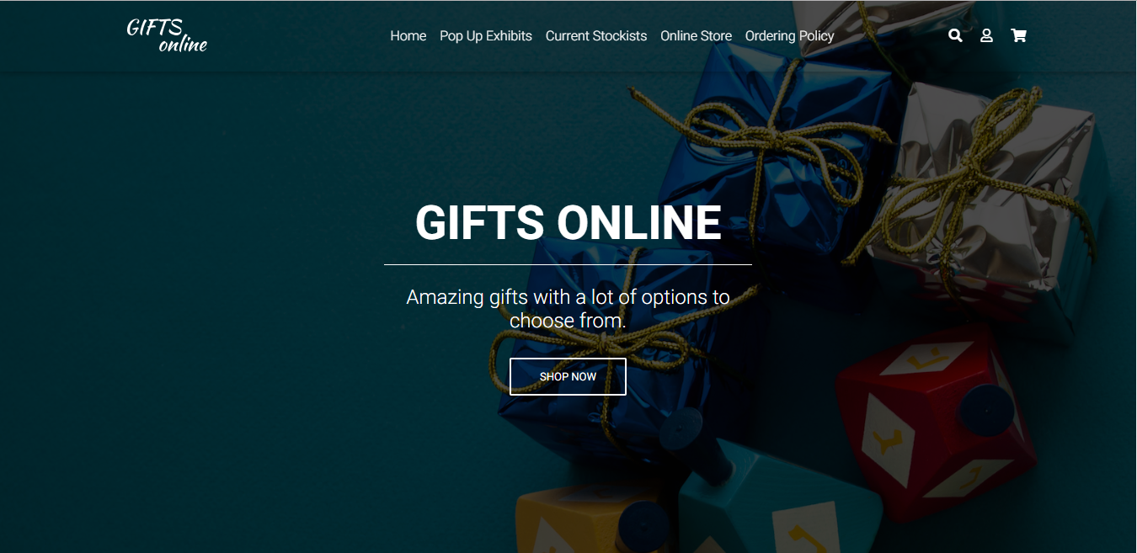

<header>

<!--Navbar-->

<nav class="navbar navbar-expand-lg navbar-dark fixed-top scrolling-navbar">

<div class="container">

<!-- Navbar brand -->

<a class="navbar-brand" href="Home.html"><img src="New Project.png" height="40%" width="50%"></a>

<!-- Collapse button -->

<button class="navbar-toggler" type="button" data-toggle="collapse" data-target="#basicExampleNav"

aria-controls="basicExampleNav" aria-expanded="false" aria-label="Toggle navigation">

<span class="navbar-toggler-icon"></span>

</button>

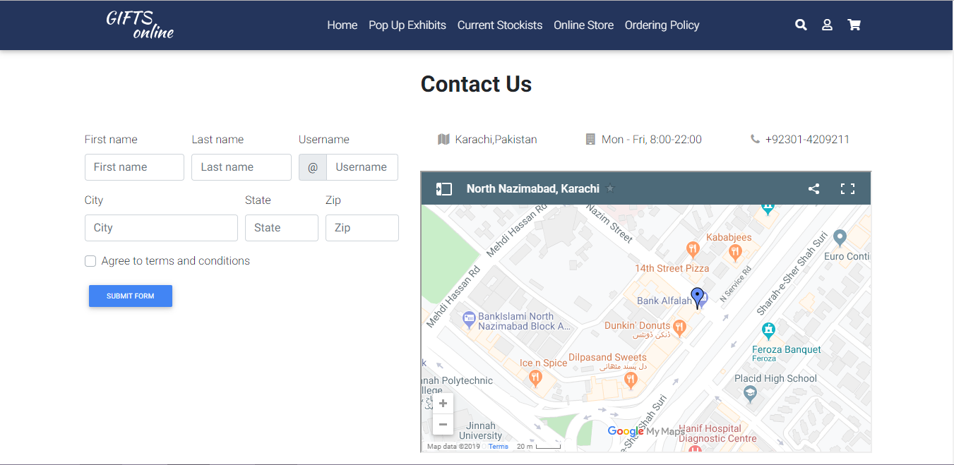CONTACT US

<section id="contact">

<!-- Heading -->

<h2 class="mb-5 font-weight-bold text-center">Contact Us</h2>

<!--Grid row-->

<div class="row">

<!--Grid column-->

<div class="col-lg-5 col-md-12">

<form>

<div class="form-row">

<div class="col-md-4 mb-3">

<label for="validationDefault01">First name</label>

<input type="text" class="form-control" id="validationDefault01" placeholder="First name"

required="" pattern="^[A-Za-z]{1,32}$">

</div>

GALLERY

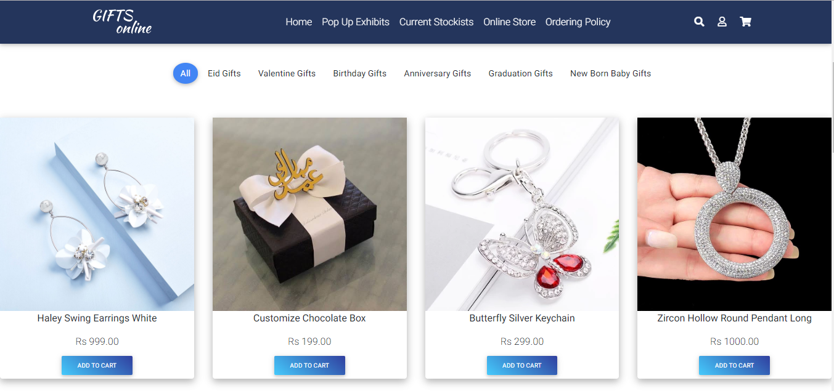

<section class="text-center my-5">

<!-- Grid row -->

<div class="row">

<!-- Grid column -->

<div class="col-lg-3 col-md-6 mb-lg-0 mb-4">

<!-- Collection card -->

<div class="card collection-card z-depth-1-half">

<!-- Card image -->

<div class="view zoom">

<img src="Eid.jpg" height="100%" width="100%" class="img-fixed">

<div class="stripe dark">

<a>

<p>Haley Swing Earrings White</p>

<h6>Rs 999.00</h6>

<a href="Cart.html"><button type="button" class="btn blue-gradient btn-sm">Add to cart</button></a>

</a>

</div>

</div>

SIGN UP

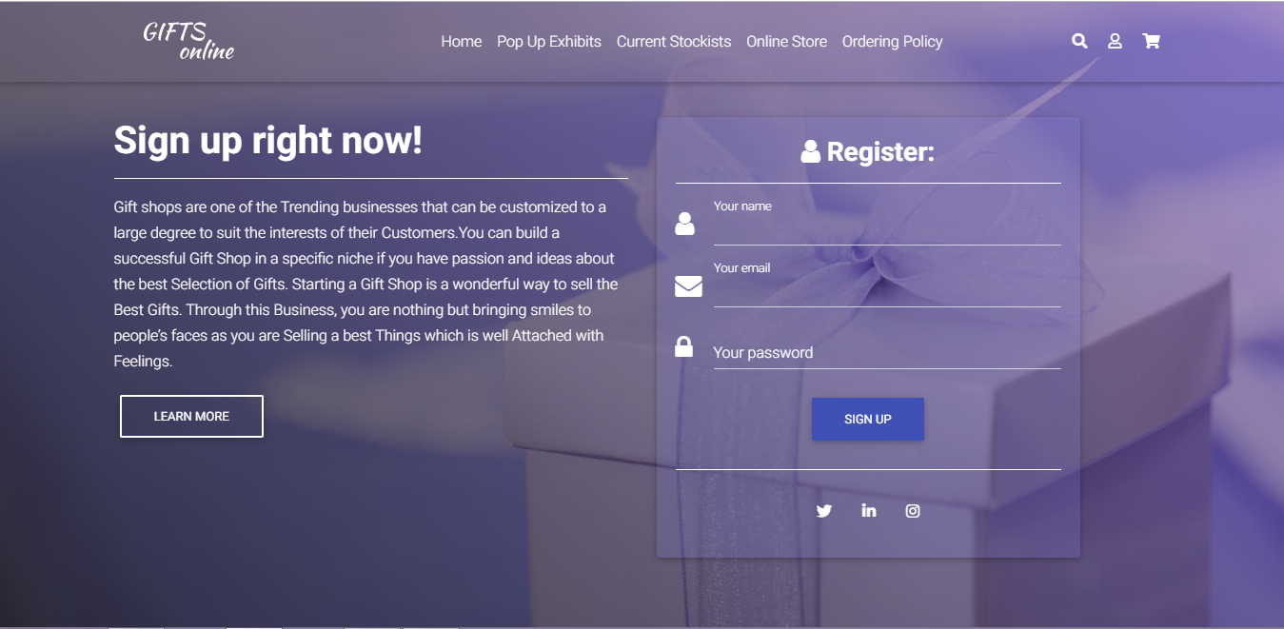

<div class="text-center">

<h3 class="white-text font-weight-bold">

<i class="fa fa-user white-text"></i> Register:</h3>

<hr class="hr-light">

</div>

<!--Body-->

<div class="md-form">

<i class="fa fa-user prefix white-text active"></i>

<input type="text" id="form3" class="white-text form-control"required="" pattern="^[A-Za-z]{1,32}$">

<label for="form3" class="active">Your name</label>

</div>

<div class="md-form">

<i class="fa fa-envelope prefix white-text active"></i>

<input type="email" id="form2" class="white-text form-control">

<label for="form2" class="active">Your email</label>

</div>

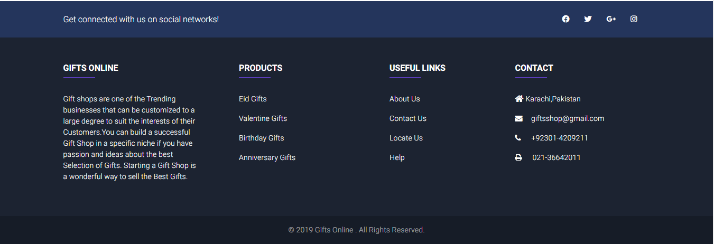FOOTER

<footer class="page-footer font-small unique-color-dark">

<!-- Social buttons -->

<div style="background-color: #24355C;">

<div class="container">

<!--Grid row-->

<div class="row py-4 d-flex align-items-center">

<!--Grid column-->

<div class="col-md-6 col-lg-5 text-center text-md-left mb-4 mb-md-0">

<h6 class="mb-0 white-text">Get connected with us on social networks!</h6>

</div>

<!--Grid column-->

<!--Grid column-->

<div class="col-md-6 col-lg-7 text-center text-md-right">

<!--Facebook-->

<a class="fb-ic ml-0">

<a href="https://www.facebook.com/" target="blank"><i class="fab fa-facebook white-text mr-4"> </i></a>

</a>

<!--Twitter-->

<a class="tw-ic">

<a href="https://twitter.com/?lang=en" target="blank"> <i class="fab fa-twitter white-text mr-4"> </i></a>